

**Portuguese Water Dog Club of Greater Chicagoland**

ANNUAL MEETING

October 14, 2023

Foster’s Training Center - Antioch, IL 60002

The meeting was called to order by President, David Parker, at 11:18 am. Members in attendance were: David Parker, Gary and Barb Novak, Michele Wolford, Carl and Patti McKnight, Carol Holzer, Theresa Hosking, Wendy Anderson, Deb Valenta, Cindy Petrey, Chris Chandler, Karen George, Leon Benson, Irene Mileos, Marsha Rosenson, and Catherine Scholz.

David Parker welcomed everybody to the 2023 PWDCGC Annual Meeting and thanked all for attending. Patti McKnight made a motion to accept the Annual Meeting minutes from Oct. 22, 2022. Wendy Anderson seconded. Motion passed.

**President’s Report**

As we emerge from the pandemic, we find our club in challenging times with a decline in membership, finances, and activity. Going forward in 2024 we are focused on getting the by-laws revised. An Action Plan has been drafted by Michele Wolford to keep us focused on key priorates . We need more volunteers to help staff various committees so we can complete our action steps, provide more value and increase interest in the club.

**Secretary’s Report**

Michele shared the Action Plan (below) which will be a living document and continually changing as work is completed, added and adjusted. Each action step will be led by a Board Member and a Member Chair/Committee to help drive accountability for the tasks and keep the club focused on our strategic priorities. We welcome all input to this work plan and **NEED MORE VOLUNTEERS**! If you want to join a committee or have an idea we should focus on that would create more value for you, please reach out to Michele or Dave.

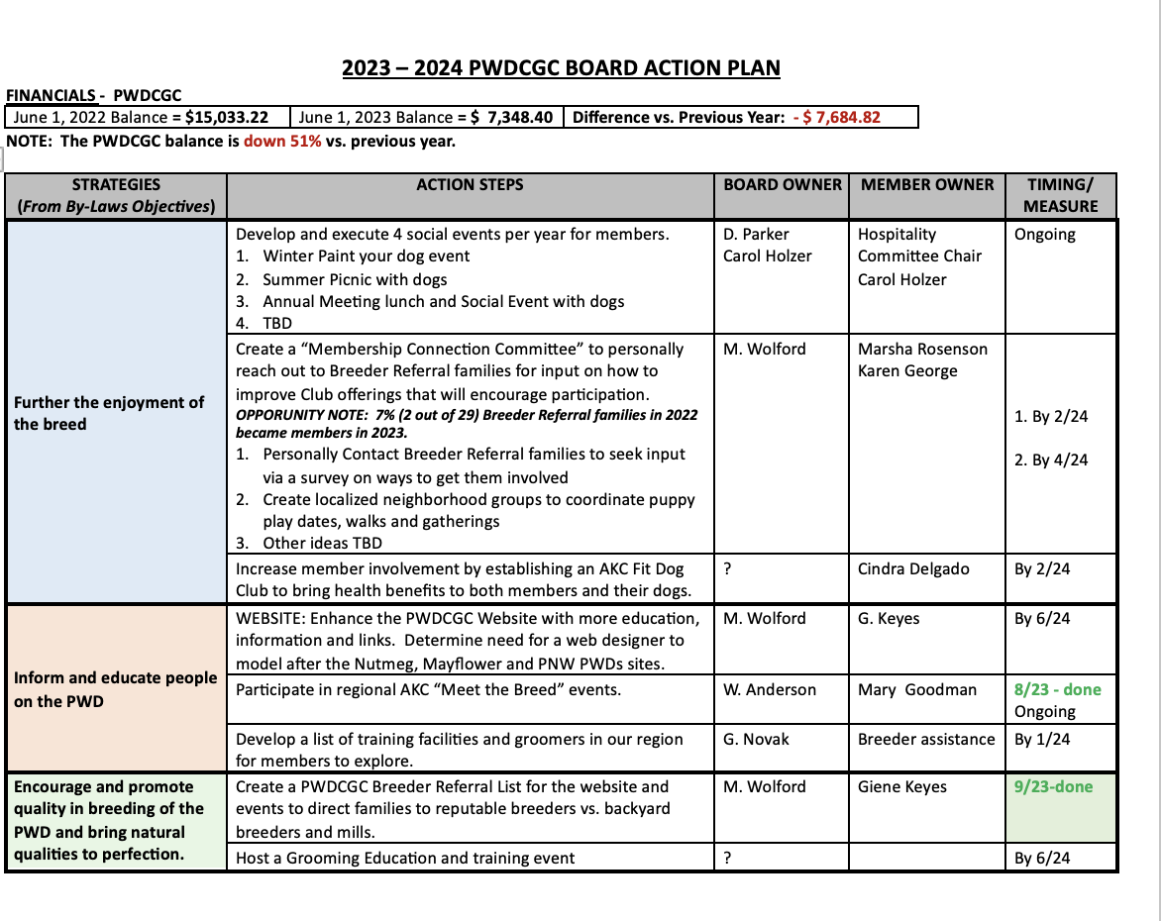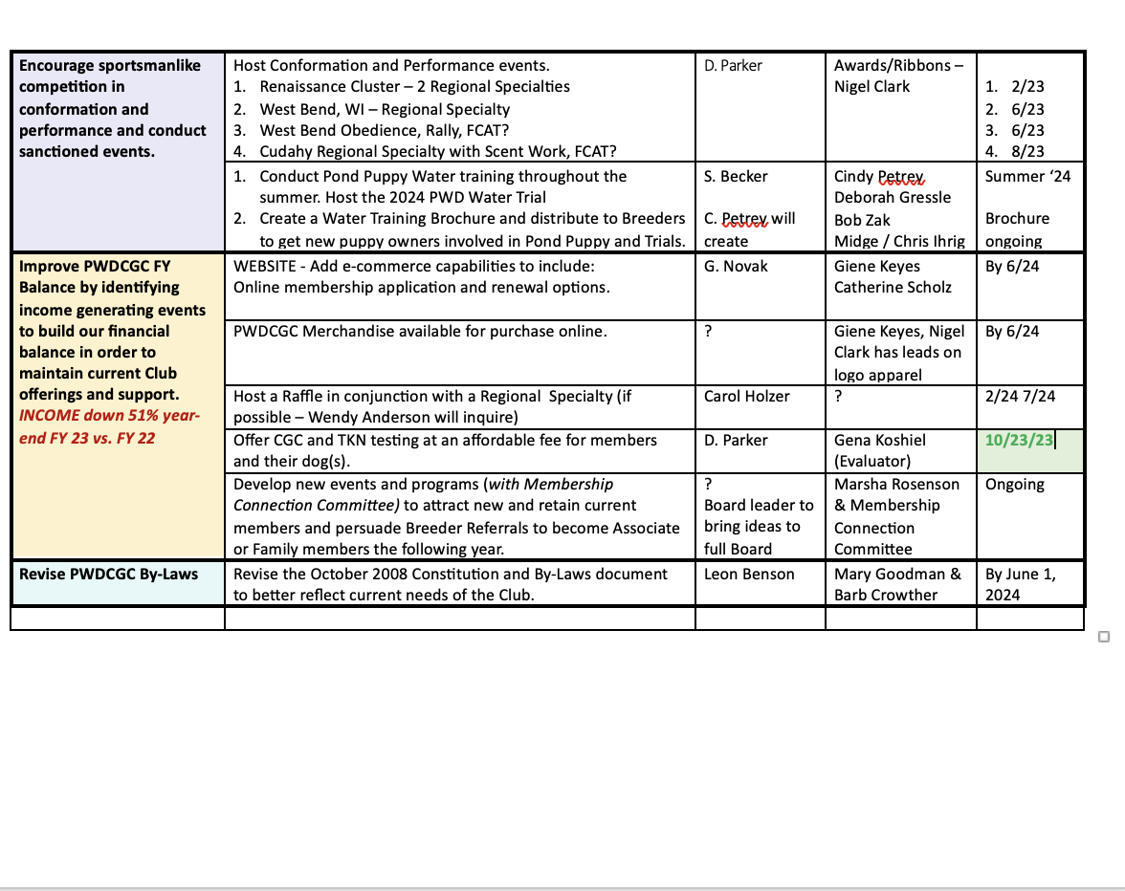

Many thanks to Karen George, Catherine Scholz, Carol Holzer, and Leon Benson who agreed to serve on a committee or lead one of the areas as a Board Owner at today’s meeting. After discussion on several of the Action Plan focus areas, Michele agreed to send out an email to Breeders to make headway on the List of Training Facilities and Groomers they recommend across our geography to share with membership. In addition to the above list of ideas, Karen George also said she is willing to do a Massage Therapy Seminar for our PWDs at an upcoming event.

**Treasurers Report:**

Gary Novak presented the fiscal year June 1- May 31 2023 vs. 2022 treasurer’s report. The PWDCGC began **June 1, 2022 with a Balance of $15,033.53**. On **June 1, 2023 our Balance was down to $7,348.40, a drop of 51%.** The main reasons for this decline was the purchase of 2 new boats and a trailer for our Water Committee. We’ve also incurred an additional fixed cost for a second storage facility. In addition to these expenses, our membership is also down again this year by $525 resulting in less income from dues. At our last Annual Meeting in October 2022 (after the boats/trailer purchase), our balance was $8,392.00 vs. $7,358.05 in October 2023, a decline of 14%.

|  |  |  |  |  |
| --- | --- | --- | --- | --- |
| **October 14, 2023 Treasurer's Report** | | | |  |
|  |  |  |  |  |
| **June 1, 2023 Balance** |  |  | **$7,348.60** |  |
| Account | Income | Expense |  |  |
| Club Expense |  | $182.22 |  |  |
| INSURANCE |  | $269.00 |  |  |
| MEMBERSHIP | $1,145.00 |  |  |  |
| Picnic |  | $228.70 |  |  |
| REFUNDS | $100.00 |  |  |  |
| REGIONAL SPECIALTY | $1,012.20 | $425.87 |  | Refund for sponsoring, Raffle sales |
| SHORELINES | $20.00 |  |  |  |
| STORAGE |  | $560.00 |  |  |
| TROPHY | $580.00 | $236.50 |  |  |
| WATER TRIAL | $2,070.50 | $3,015.96 |  | Awards, judge's fee, food, porta-potty |
|  | $4,927.70 | $4,918.25 |  |  |
| **Checking Account Balance 10/10/23** |  |  | **$7,358.05** |  |

With the need to rebuild income for the Club, Dave made the decision last year to move from doing Designated Specialties to hosting only Concurrent Specialties. Historically, the Designated Specialties cost the Club money but the Concurrent Specialties allow us to share some of the profits with the hosting Kennel Club. By doing this, we’ve been able to either break even on the events or make a small profit which previously had been an expense. We will continue with this plan in 2024 with two Concurrent Specialties in Madison Wisconsin in February at the Renaissance Cluster and perhaps a third Concurrent Specialty at West Bend, WI at the end of June which will include performance events as well.

Another income generating activity is having a raffle at these Specialties, however Wisconsin requires a permit to conduct them. Wendy Anderson agreed to check into getting a permit so we can host a raffle in February and/or June. Carol Holzer agreed to work with Wendy on Raffles and help lead them if we are able to get a permit.

Patti asked if we could do a Specialty or Performance event in DeKalb. Dave said the concern was the lack of Camper/RV space which is a barrier to drawing participants. Waukesha, WI may be an option. We’d like to start doing Performance events on Friday and the Specialty on Saturday so conformation dogs can do both. Dave will investigate Waukesha.

**Membership Committee:**

This year our membership dues collection is $1,100 vs. $1,670 last year. Several years ago the club had over 250 members and now we are down to about 150. Currently we charge $10 for a Breeder Referral membership, $25 for an Associate member (non- voting status), $30 for a Single voting membership, $35 for a Family membership. Marsha asked when we last raised membership dues. No one in the club had any memory of raising the fee. Marsha suggested the Board consider raising Membership dues to help raise income, especially since costs have risen so much in the last decade. Dave said according to the by-laws we can only go up to $50 unless by-laws are revised. The Board will discuss and consider this for 2024. Dave said we need reinvigorate the Club and focus on that Action Plan to provide a benefit to the membership if we raise the dues. Marsha said she will do her part and begin creating a map of our membership so we can get people who live in closer proximity to others connected locally to do activities in small groups with their dogs. Any fresh ideas to increase involvement and value are welcome.

**Water Committee Written and Submitted Update**

“Although we had a bit of a late start with our summer program, we had a successful season culminating with our water trial at the end of August. The numbers were down for our pre-season, dry land seminar, but we welcomed some new members and everyone who attended made good progress with the foundation skills covered.

The August heat did not deter the participants in our August water trial. Our trial numbers were down somewhat from last year, but thanks to our tireless volunteers and Judge Karen Pratt, things ran smoothly and everyone had a good time. We have tentatively set August 24-25 or September 21-22 for our 2024 trial.”

*A few members said the August dates overlapped with the Lake Elmo Show. David asked the Water Committee to determine how many Water Trial participants are also show dogs to better understand this potential conflict. He asked if mid-August was considered, but the committee felt it might be too soon as people need time to prepare and practice.*

“Our main hurdle this season was setting a venue for our weekly pond puppy training sessions. The several options we explored either proved too expensive or not appropriate for our needs, so we decided to simply utilize our trial site at Lake Andrea for our weekly training. As this is a public park, we faced a few new issues, but overall, we had a successful season. The biggest change in our program was that the boats and markers had to be stored off-site between practice sessions. The trailer we purchased last year was put to good use. The committee would like to thank all the volunteers what came early and stayed late each week to help unload and reload the trailer. And, we are especially thankful for Bob Zak and Chris Ihrig who hauled the trailer to and from each week.

Looking ahead…We are currently re-evaluating our pre-season seminar to hold a Novice Beginners one day only session at Fosters. This could be an early season run-thru for newcomers to get an understanding of the whole picture. At this time, we plan to continue with our summer training at Lake Andrea next year.”

*Cindy Petrey brought up the idea of creating a Brochure that describes Water Work and Water Trials that could be given to breeders to hand out when they send puppies home. The brochure will include information about Pond Puppies and how to get started. Michele will add the brochure idea to our Action Plan. Cindy agreed to lead this work and Patti McKnight said she and likely many other breeders would happily distribute those brochures.*

Dave provided sincere gratitude on behalf of the Board for all the extra work the Committee did this year to make the training session and Water Trial so successful.

**By-Laws Committee:**

No report. Leon agreed to lead this work for the Board and help Barb Crowther (recently added to the committee) and Mary Goodman (Committee Chair) complete this task.

**Nominating Committee and Board Election:**

The 2023 PWDCGC Nominating Committee met in August to select our slate of Board nominees. We held a vote for the re-election of several Board Members who will be serving a second term (see slate below). None of these members were opposed. We also received a nomination from a Club member for Leon Benson who will fill an open Board Director seat. We had quorum today at the meeting. Gary Novak passed out voting ballots. Patti made a motion to approve the slated nominees, Cindy seconded the motion. Motion carried unanimously.

Election of Officers: Unopposed include:

President, David Parker (returning)

Director, Susan Becker (returning)

Director, Theresa Hosking (returning)

Director, Dr. Leon Benson (new board member)

Director, OPEN SEAT – Jim Cowhey resignation.

David shared his appreciation for Cindra Delgado’s service to the board. She made the decision not to run for re-election. Jim Cowhey made the decision to resign after one year of his two-year term. His vacancy does not require a membership vote and the board can seat someone. We are looking for a new member. So if interested, let us know.

**Board Approval of New Members:**

New members that were voted on today were Catherine Scholz, Michael & Hailey Schroeder and Linda and Constantine Bitsis. Deb Valenta made a motion to approve new members. Gary seconded the motion. All were in favor. Motion carried. Welcome to our new club members!

**Unfinished Business:**

None

**New Business:**

* David asked for approval to order rosettes for upcoming shows in 2023. Approval granted.
* David asked that we accept Irene Mileos as a new member from the Breeder Referral program. Motion was approved. Gary provided Dave with paperwork to complete Irene’s membership. Welcome Irene!
* Dave asked meeting participants about a date for the Annual Picnic. Several June dates were offered but due to Father’s Day and other potential conflicts, Michele suggested we try doing the picnic earlier in the year, before families get too caught up with summer conflicts. All agreed it was worth a try. The Annual Picnic will be held on either May 18th  or May 19th based on availability at the Picnic site (same location)

Marsha made a motion to adjourn the meeting. Barb seconded the motion. All in favor.

Annual Meeting adjourned at 12:30 PM.

**\***Several dogs took their CGC and TKN tests successfully earning new titles. Congrats to all who passed!